Agenda:
11:20-11:30 Launch Web 2.0 & Tool 1
11:30-12:10 Tool 2 – Tool 5
12:10-12:20 Summary_Exit Slip/Poll

Intro:
Cell phones on table – left hand corner, off
Introductions at table – who are the people you will be working with?
Intended Learnings and Agenda

Who are we?
1
Tool 1 Pew Research Center - Take the Pew Research Center Millennial Quiz
How could the information about Millennials help/hinder my work?

Who are our students?
Tool 2 Poll Everywhere & article
2
Poll Everywhere replaces expensive proprietary audience response hardware with standard web technology. It's the easiest way to gather live responses in any venue: conferences, presentations, classrooms, radio, tv, print — anywhere. And because it works internationally with texting, web, or Twitter, its simplicity and flexibility are earning rave reviews.

Use your cell phone or computer to answer these two questions:
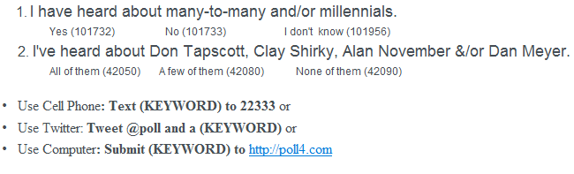

How can you use Tool 2 in a mathematics class?

How can you use Tool 2 in a Team Meeting?

How can you use Tool 2 in a Professional Development?

Tool 3 Website creators: Weebly
3
Weebly is an online, free, widget-based Web site creator, funded by micro-seed fund Y Combinator. It uses a widget style format, allowing users to create pages with only a few clicks by dragging and dropping different page elements (images, text, or interactive content, etc.) onto a page and filling in the content

a) View Don Tapscott video
How could this information about “digital natives” impact classrooms/PD/meetings?
b) View Clay Shirky video
What could many-to-many look/sound like in classrooms/PD/meetings?
c) Retrieve documents

How will mathematics teachers use Tool 3?

How will mathematics students use Tool 3?

Tool 4
4
Wiki/Google Docs
A Wiki is a website that allows the easy creation and editing of any number of interlinked web pages via a web browser using a simplified markup language or a WYSIWYG text editor. Wikis are typically powered by wiki software and are often used to create collaborative wiki websites, to power community websites, for personal note taking, in corporate intranets, and in knowledge management systems.

a) AISD Curriculum Writing PBWorks site
b) AISD Numeracy Committee Plan PBWorks site
c) AISD Mathematics Team Google Docs

View Dan Meyer video
How should/could mathematics instruction change to meet the needs of current students?

How will mathematics teachers use Tool 4?

How will mathematics students use Tool 4?

Tool 5 – Cool Stuff!
5a

Top 10 Web 2.0 Must Haves for Every 21st Century Classroom
http://web20guru.wikispaces.com/Web+2.0+Resources

- Class Blogs - Wordpress or Blogger
- Class Wiki or Website - Wikispaces, Wetpaint, Webnode, Wix, Glogster WikiMatrix - compare and contrast
- Virtual or a Cloud Office - Docs, Google Docs, Office Live , Zoho, Thinkfree >
- Online Classroom Environments/Networks/Forums - Ning, Neetz, Lefora
- Backchannels - tinychat, backnoise, coveritlive
- Audio Channel - Podcasts or recordings - evoca,podbean, gabcast, gcast, odeo
- Teacher Tube Kidstube - create a free account for uploading demonstrations
- Private Videocast or TV Channel - Ustream Mogulus., Youcastr
- Online Assessment tools - Thatquiz. , rubrics - Tech4Learning
- Online Grade book -Engrade
- Online storage - file storage - Box.net Adrive , 4shared, Flickr Google Docs - for docs, pics and more
5b
Online FREE great mathematics games! NCTM, Skill Builder, Oswego

How will mathematics teachers use Tool 5? How will mathematics students use Tool 5?

Please fill out the Exit Slip:
